Notes Taken by:
- Danica Marie F. Supnet, Institute for Climate and Sustainable Cities
- Jihyung Joo, University of Leeds
- Towrin Zaman Raya, Independent University, Bangladesh
- Ziqun Jia, Perspectives Climate Research Group

Day 1: Tuesday, 9th July
Provisional schedule for first day

Opening of the session
- Ji-Young Choi, the Deputy Minister for International Affairs at the Ministry of Economy and Finance of the Republic of Korea, highlighted COP28 as a significant milestone in climate action. He emphasized the undeniable need for financial support and announced South Korea's voluntary contribution of USD 7 million to the FLD. Choi also expressed Korea's willingness to share its knowledge on climate change response and green transitions.
- Mukhtar Babayev, the COP29 President-designate, emphasized the importance of adopting a work plan for 2024 with clear objectives during the B2 meeting. He stressed the critical steps of selecting the Executive Director and the host country, highlighting the urgency of making the fund operational to ensure that those affected by climate impacts receive resources as soon as possible. Babayev also called for significantly more contributions to protect the most vulnerable populations.
- Ambassador Thompson of Barbados provided a stark account of the recent devastation caused by Hurricane Beryl in Latin America and the Caribbean. She stressed that the fund must reflect the magnitude and urgency required to respond to such disasters, calling for actions that go beyond small community grants. She urged for substantial and rapid responses to meet the needs of the most vulnerable, emphasizing that discussions cannot continue while people are suffering and living in crisis.
- Personnel Changes: Armenia's new board member, Nona, and the replacement of Christina Chan by Alexandria Miskho from the US
Board Discussions and Decisions

Host Country Selection
- The Philippines was selected as the host country for the board of the Loss and Damage Fund. Mark Dennis Joven (Philippines) expressed gratitude and commitment to moving quickly with the FLD.
- Members emphasised the urgency of operationalizing the FLD to meet the needs of developing countries noting that this decision was key milestone adopted. Ambassador Adou from Timor Leste highlighted the recent tragedy in Nepal, where 74 people lost their lives due to climate-related disasters, stressing the need for the fund to be dispersed soon to address such urgent needs. These discussions and decisions reflect the collective commitment to operationalizing the FLD and addressing the needs of vulnerable communities affected by climate change.

Interim Arrangements and Procedures
- Adopted an interim code of conduct and ethics for the board.
- Adopted interim procedures for decisions between meetings, including a voting procedure if consensus is not possible.
- Agreed to use the contingency budget to provide funded support for developing country alternate members for this meeting, with the hope of resolving this with a travel policy.

Adoption of Agenda and Reports
- Adopted the revised agenda to include a dialogue with civil society.
- Adopted the report of the first meeting of the board.
- Discussed the need for better communication and coordination, particularly the timely sharing of documents.

Interim Secretariat Report
- The interim secretariat presented its report, highlighting efforts to support the co-chairs and the board, the preparation of documents, and engagement with observers.
- Agreed to structure future reports around the adopted work plan to improve efficiency.

Dialogue with CSOs
Active Observers were given the floor at the end of the day.
- The participation of active observers in the governance of the Loss and Damage Fund (LDF) is crucial for ensuring transparency, accountability, and inclusiveness. Civil society organizations (CSOs) emphasize the need for coherent and comprehensive participation modalities that go beyond established practices in other climate funds. Active observers should represent rights holders and marginalized groups, with a focus on meaningful participation at all levels, from policy-making to implementation and monitoring. This includes self-selection procedures, equal footing in discussions, timely and complete access to documents, and financial support for participation. CSOs advocate for prioritizing representation from the Global South and providing capacity building and technical assistance to Indigenous Peoples, youth, women, and other members of civil society. Additionally, local communities should be actively involved in project design and implementation through community consultations and needs assessments.
- The development of a robust travel policy is essential to support the effective participation of active observers, particularly from developing countries. It was noted that many developing country observers were excluded from attending due to the cost constraints CSOs highlight the undue burden caused by the lack of travel support, which prevents many from attending important meetings. The travel policy should provide financial support for travel and capacity-building activities, ensuring that those from affected communities, Indigenous Peoples, youth, and marginalized groups can participate fully in the Board's proceedings. This support should be reflected as a dedicated line item in the administrative budget to ensure consistency and reliability.
- Access modalities are a critical area where CSOs call for a clear and holistic definition of direct access, allowing entities in developing countries to receive and manage climate funds directly, without intermediaries. This approach should prioritize community consultations and flexible, adaptive grant-making processes. CSOs strongly support the establishment of a community access window to ensure funds serve community-centered approaches, with devolved decision-making and small grants funding. Direct access should be integrated into a broad framework across the fund, emphasizing community ownership and streamlined disbursement mechanisms to enhance the fund's impact.
- Regarding financial instruments, CSOs express concerns about the appropriateness of certain financial modalities for addressing loss and damage. They advocate for grants and non-debt-creating instruments, emphasizing that the fund should not impose further harm through debt. The analysis of financial instruments should consider climate justice principles and the community context, avoiding complex and inappropriate instruments like guarantees and blended finance. The fund should prioritize traditional project/programme support, direct budget support, and community direct access to ensure effective and equitable distribution of resources.
- The additional rules of procedure for the Board should enhance transparency, accountability, and inclusiveness, aligning with active observer procedures and broader stakeholder engagement. All meeting documents should be publicly available and shared with observers simultaneously with Board members. Additionally, hybrid meetings should be established as the standard procedure to allow meaningful virtual participation, ensuring broader accessibility and engagement.
- Finally, the operationalization of the Loss and Damage Fund as a Financial Intermediary Fund (FIF) under the World Bank raises significant concerns. CSOs highlight the World Bank's existing policies and support for fossil fuel funding as incompatible with the LDF's mandate. They stress the need for the fund's full autonomy, protection of eligibility for all developing countries, and the establishment of direct access as the dominant access modality. Accountability and public disclosure are essential to ensure the fund's independence and compliance with COP/CMA conditions, with full transparency in the FIF documentation and hosting agreements.

Responses from board members and answers by observers:
Mohammad Ayoub (Saudi Arabia)
- Thanks CSOs for their substantive interventions and emphasizes the importance of concrete examples and case studies to guide the Board.
- Highlights the need for more coordinated preparation and response time for documents and to think of creative ways to include inputs.
- Asks how the fund can best address the needs of those on the frontlines
- Also noted importance of resource mobilisation strategy
- FARMERS: "We are ready to share substantive stories about how we are impacted and dealing with climate change. For example, in Indonesia, farmers are dealing with a heatwave and flooding, which prevents them from crossing rivers. We help our farmers grow from scratch using agroecology, enabling them to harvest quickly despite challenges."
Gerard Howe (UK)
- Describes the interventions as extraordinarily rich and suggests turning them into a richer dialogue.
- Emphasizes the importance of localization and working with local communities and households.
- Supports the idea of a community access window and the need for an inclusive vision of the fund.
- Isatis Cintron - ENGO-CAN: "We want to be seen as your partners. This dialogue is one of the few chances we have to share our thoughts. We have examples and lived experiences that we would like to share. It would be great to hear what has worked and what could be done better, ensuring that the fund addresses the needs of people on the ground."
Djibril Ibila (Benin)
- Appreciates the relevant statements and asks about the operationalization of the direct access window, specifically how to define/select communities to benefit from the LDF.
- Harjeet Singh - Fossil Fuels Non-Proliferation Treaty, ENGO-TUNGO: "Direct access is essential to avoid conflicts of interest and self-interest seen with intermediary organizations. We advocate for national and community-based organizations to have direct access, ensuring planning, monitoring, and implementation are effective and centered on the needs of those affected."
- Adrian Martinez - La Ruta del Clima, ENGO-DCJ: "We need to ensure the participation of vulnerable communities, involving them not only in conditions but also in proactive outreach. This will generate benefits in process and implementation. Communities dealing with loss and damage have invaluable knowledge and experience."
Laurence Ahoussou (Canada)
- Asks about ensuring safeguards before disbursement and how to make progress on implementation.
- Seeks examples of successful small grants and trade-offs.
- Grace Balawang - IPO: "Integrating local knowledge and examples of successful community-led initiatives is key. For instance, applying the principle of free, prior, and informed consent ensures safeguards and effective community engagement in planning, implementation, and monitoring."
- Harjeet Singh - Fossil Fuels Non-Proliferation Treaty, ENGO-TUNGO: Shared an example from the Pacific: In the Pacific, the Pacific Conference of Churches (PCC) has taken significant steps on behalf of regional civil society organizations by supporting the Kioa Declaration and taking the Kioa Pledge. This initiative aims to establish the Kioa Finance Mechanism, which supports Pacific Island communities affected by climate change. The PCC is actively reaching out to partners to support local communities in small to medium-scale adaptation projects. The PCC has existing safeguard policies in place. PCC can receive funds and be a regranter.
Rebecca Lawlor (USA)
- Inquires about including affected communities like climate migrants and thoughts on the AO paper's nomination process.
- Harjeet Singh - Fossil Fuels Non-Proliferation Treaty, ENGO-TUNGO: "Flexible active observer representation is vital to include diverse community voices. We need to ensure that those affected, including climate migrants, are represented and heard."
Alpha Kaloga (Guinea)
- Recognizes the critical need to address immediate and long-term loss and damage.
- Supports integrating local knowledge, greater transparency, and inclusivity, and emphasizes the fund's focus on grants or highly concessional loans.
Jens Fugl (Denmark)
- Finds the interventions useful and suggests receiving detailed comments in advance.
- Questions the practicality of direct access without intermediaries and seeks practical ideas for operationalization.
- Harjeet Singh - Fossil Fuels Non-Proliferation Treaty, ENGO-TUNGO"Direct access is crucial to avoid conflicts of interest and ensure community ownership. We've seen intermediaries turn this into a business model. Direct access should include national and community-based organizations to ensure effective and equitable implementation." Highlight successful examples and initiatives like the Kioa Finance Mechanism in the Pacific.
- Liane Schalatek - Heinrich Böll Foundation, WGC: "Access modalities should ensure direct and practical pathways for communities. Looking at existing models like the GCF readiness program can provide valuable insights. We need to bring people from the frontlines into the discussion, encouraging early submission and virtual participation to gather diverse perspectives."

Day 2: Wednesday 10 July
Provisional Agenda

Access modalities, background paper, in relation to relevant indicators, triggers including functional equivalency:
Jean Christophe: Commended the interim Secretariat's work and encouraged linking access modalities to the Fund’s business model, suggesting a move from descriptive to policy-oriented discussions.
Interim Secretariat: Presented key aspects of the document on access modalities, emphasizing country ownership, simplification of processes, and flexible triggers for rapid and programmatic support.
Rebecca (US): Proposed structuring discussions around responses to different events, emphasizing the importance of national response plans, small grants for rapid events, and long-term financing assurances.
Sebastian (France): Stressed the need for coordination and coherence in national plans, rapid support for the most vulnerable, and accessibility without bureaucratic hurdles, suggesting consideration of insurance mechanisms.
Daniel (Fiji): Highlighted the need for a programmatic approach led by national leadership, advocating for direct budget support and emphasizing national ownership and response.
David Kaluba (Zambia): Agreed with prioritizing direct budget support and utilizing accredited entities like the Adaptation Fund and GCF, emphasizing the need to understand different types of losses and events.
Mo (Egypt): Reiterated the use of existing accredited entities without re-accreditation, advocating for simplified processes and focusing on programmatic approaches through direct budget support.
JC: Emphasized starting from the Governing Instrument and developing specific approaches for the Fund, acknowledging the role of insurance mechanisms.
ENGO/Brandon: Called for clarity in defining direct and community access, emphasizing consultations with observers and the principle of subsidiarity in funding decisions.
Adao (Timor-Leste): Proposed three ways to access the Fund for LDCs, emphasizing accountability, country ownership, and using existing accredited entities to speed up the process with simplified standards.
Jens (Denmark): Supported the paper and stressed linking access modalities to the Fund's goals. He emphasized the need for diverse options and adapting modalities to different national contexts.
Mohammad (Saudi Arabia): Agreed with the inclusivity in thematic areas and streamlined re-accreditation. He highlighted the need for broad access, translation of documents, and caution against extending the Fund's scope to non-climate issues.
Elena (Honduras): Focused on translating discussions into practical decisions and required policy documents to guide the Board.
Ronan (Ireland): Supported more intersessional work, fast-tracking accreditation, and improving community access through small grants. He emphasized these should complement other modalities.
Tunga (IPO): Emphasized culturally appropriate funding for Indigenous Peoples and supported direct access and community-based approaches.
Djibril (Benin): Advocated for direct budget support for LDCs, programmatic approaches for slow onset events, and capacity building.
Gerard (UK): Supported evidence-based decisions, country ownership, and programmatic approaches. He highlighted the need for a phased approach and evaluating small grants based on impact.
Antonella (Italy): Called for a comprehensive and adaptable framework with tailored access modalities and a staged approach to implementation.
Laurence (Canada): Supported a strategic discussion, fast-tracking accredited entities, and addressing challenges at the community level.
Alpha (Guinea): Stressed the need for capacity building, flexible funding, and reducing reliance on intermediaries.
Elizabeth (Barbados): Raised concerns about regional banks’ roles and the need for scalable interventions, avoiding a small-scale approach.
Jose (Austria): Supported maintaining resolved issues and diverse access modalities. He highlighted the need for quick responses to short-term challenges.
Farmers Constituency: Shared positive experiences with community direct access and emphasized the benefits of community-driven financing models.
Maria (Argentina): Supported recognizing accredited entities and using varied triggers for accessing funds, and suggested a sub-committee for further discussions.
Mo (Egypt): Proposed confirming accredited entities, flexible direct budget support metrics, and developing papers on flexible standards. He stressed simplifying access mechanisms.
Rebecca (US): Called for resolving structural issues comprehensively and aligning actions with the Fund's goals.
JC: Acknowledged the discussion and stressed the need for clear guidance and realistic expectations before proceeding with financial instruments and other agenda items.

Travel Policy
Richard: Agreed to use the contingency fund for Board members and acknowledged inconsistencies in the travel policy. Mentioned proposals outlined in paragraph 2 and emphasized the need for further discussions. Highlighted the importance of having a full board present for crucial discussions and planned to present a paper on risks and mitigation strategies.
Atsushi: Emphasized the importance of equal and fair representation and efficient resource use based on needs. Raised concerns about coverage and eligibility, suggesting support should be limited to specific countries. Requested a benchmark analysis for better understanding.
Jens: Agreed with Atsushi on three key principles: equal and fair participation, minimizing carbon footprint by reducing travel, and ensuring cost-effectiveness and efficiency. Advocated for a transparent approach to demonstrate responsible resource use.
Mohammad Ayoub: Highlighted the need to understand cost implications and ensure resources are allocated based on genuine needs. Criticized questioning the needs of developing countries and stressed the benefits of in-person meetings. Pointed out double standards on environmental impact and noted the significant portion of funds going to operating costs.
Adao: Stressed the need for inclusiveness for LDC representatives and emphasized that the travel policy should cover full participation for board members, alternates, and advisors.
Mo: Thanked the Co-chairs for involving board members and advisors. Highlighted the challenges of remote participation and suggested using airlines with efficient fuels to address carbon footprint concerns.
Rebecca: Requested information on costs and emissions implications of potential travel policy changes. Noted that not all developing countries receive reimbursement due to opting out and sought clarity on the causes.
Jose: Advocated for a phased approach and improved governance, rather than ad-hoc solutions. Suggested considering the carbon footprint and setting a role-model example for other funds.
Mohammad A: Recommended a collective board discussion on the paper for transparency and effectiveness, rather than individual consultations.
Richard (Follow-up): Promised to present a paper soon and emphasized the need to finish early due to committee requests.

Financial instruments, modalities and facilities
Richard: Warned of strong suggestions to avoid circular discussions on financial instruments and modalities.
Interim Secretariat/GCF: Prepared the document as per para 22 of GI, detailing modalities, instruments, and examples from various funds. Initiated deliberations on developing policies for grants and concessional loans. Provided a summary of financial principles and proposed a phased approach, starting with grants and concessional loans, expanding to more complex tools later.
Richard (South Africa): Advised against a top-down approach, focusing instead on addressing specific country needs. Suggested a principle-based policy-making approach and proposed a discussion on exploring new strategies versus traditional methods.
Mark (Philippines): Criticized table 1 for misrepresenting guarantees and stressed understanding all financial instruments. Advocated for mobilizing resources and ensuring complementarity with other funding mechanisms, including regional facilities supported by Japan.
Gerard (UK): Emphasized the function of the Fund over the form of financial instruments. Stressed aligning objectives with targets and improving lives through effective use of funds. Supported creating a framework for action based on the discussions.
Jose (Austria): Supported a targeted approach to address fragmentation in financial instruments.
Mohammad (Saudi Arabia): Highlighted the need to consider the scale of funding and its impact on instrument choices. Requested clarification on the use of credit lines and terms for rapid response funding.
Richard (South Africa, Follow-up): Clarified pre-arranged finance as advance finance for rapid deployment.
Adao (Timor Leste): Preferred grants over concessional loans for LDCs to avoid additional debt burdens. Emphasized solidarity and climate justice, and favored a grant-based approach.
Alpha (Guinea): Supported starting with grants and highly concessional loans, opposed large private sector involvement, and requested a clear definition of pre-arranged finance.
Daniel (Fiji): Endorsed a country-led bottom-up approach, emphasizing national-level solutions and addressing funding gaps.
TUNGO (Harjeet): Highlighted existing social protection schemes like BISP and stressed mapping these for effective implementation.
Richard (Follow-up): Asked observers to submit written statements.
Sebastian (France): Found the discussion helpful, stressed focusing on the most vulnerable, and supported using grants. Advocated for a programmatic approach and preparing countries for loss and damage.
David (Zambia): Emphasized defining the Fund’s vision and objectives. Stressed the need for clarity on economic and non-economic losses and appropriate financial instruments before detailed discussions on access modalities
Djibril (Benin): Focus on grants and highly concessional loans as stated in paragraph 57. Grants are crucial for LDCs, and there’s a need for rapid fund availability. Questions remain about the activation process and vehicle for funds. Consider creating rapid response triggers for grants/concessional loans initially, with other instruments evaluated later. Grant financing is a matter of environmental justice.
Hana (UAE): The detailed discussion on needs aligns with identified gaps and is useful. The Fund must adapt and should not replicate the GCF or GEF. Avoid increasing debt burdens by focusing on grants and simple financial instruments. Agility in governance is important; avoid transplanting existing instruments. Clarify scale and business model to effectively use instruments.
Jens (Denmark): The paper should shift focus to vision, business model, and operational details of the Fund. Emphasize a country-driven approach and consider national models and existing social protection networks. Prepare for B3 by addressing these elements.
Mo: Discuss safeguards and high standards for fund utilization. The Fund needs to ensure rapid responses for recovery, reconstruction, and rehabilitation, with a focus on non-debt creating, highly concessional financing. Develop fiduciary standards based on agreed principles.
Richard: Agreement on key points with Rebecca/US; this is a historic moment.
Ronan: Appreciate the intervention; ensure substantive discussions for B3 and B4. Additional time for discussions before B3 would be beneficial. Value civil society input, particularly on gender-responsive and locally-led principles.
Laurence (Canada): Agree with Richard’s points; more analysis is needed. The Fund should address country needs without shortcuts. Discuss allocation and integrate financial analysis while recognizing community-based actions.
Interim Secretariat: Grants and direct budget support depend on donor criteria. Examples from the EU and ADB show direct support can reduce transaction costs. Pre-arranged financing varies and includes mechanisms like credit lines.
Other Interim Secretariat Person: Pre-arranged financing includes various mechanisms like insurance and catastrophe bonds. It should be dynamic, innovative, and have multiple types and triggers.
Interim Secretariat Presenter: Emphasize flexibility; time-based and scenario-based approaches are crucial.
Alisher: Thanks to BMs; the summary on risk facilitators and social protection schemes was not exhaustive.
Richard: Closing agenda items; will capture actionable paragraphs for the work plan. Consider Chatham House retreat; circulate travel policy principles.
JC: Discuss annual high-level dialogue arrangements. Options for timing and location need board positioning.
Sebastian: Conduct the first high-level dialogue before COP29. The dialogue should enhance understanding of the Fund and its symbolic start is important. Be pragmatic with time constraints.
WGC: Set vision and scope; consider innovative resource allocation.
Mo: The dialogue should be meaningful; avoid formalities. Consider a virtual dialogue in 2024 with more substantial engagement in 2025.
Hana: High-level engagement on the Fund's vision and business model is needed. Address gaps and explore opportunities like the FFD Dialogue in 2025.
Atsushi: The Fund should integrate with existing L&D systems. Ensure efficient and connected dialogue on financial arrangements.
Ronan: Preferred the HLD to occur in October to signal the Fund's operational status. Emphasized the need for coherence with other funding arrangements and was flexible, though favored an in-person meeting in October. Virtual options were considered.
Mohammad: Faced dilemmas including feasibility issues with an October date, concerns about capacity and timing relative to COP, and uncertainties around costs, logistics, and resource allocation. Suggested prioritizing funding for alternates and advisors over the HLD if necessary. Considered a virtual HLD as a viable option if resources were limited.
Laurence: Saw value in holding the HLD this year to maintain the Fund’s prominence but noted that the board was still working out the dialogue’s purpose. Suggested that while issuing recommendations might not be possible this year, a meeting should still take place.
Gerard: Agreed on the importance of signaling and coordination. Suggested that the HLD could be held alongside another event, like the Finance for Development conference, to reduce additional travel.
David: Preferred postponing the HLD to 2025 to better prepare and present a credible case. Emphasized the need to focus on foundational issues and ensure proper representation before holding the dialogue.
Adao: Highlighted the HLD’s importance for political guidance and complementarity. Mentioned ongoing work on the host country and showed flexibility for a 2025 date.
Elena: Noted that the HLD needed to be co-convened with the UNSG and that there was no concrete proposal on access modalities. Advocated for early 2025 to allow adequate preparation and development of the Fund’s vision.
Pierre: Agreed that not having the HLD in 2024 could send a negative signal. Weighed the pros and cons, suggesting venues like the World Bank Annual Meetings or virtual options to avoid additional travel.
Georg: Supported holding the HLD this year to establish the dialogue and counter initial ideas. Suggested the Finance for Development conference as a potential venue and emphasized deciding on future dialogues as well.
Rebecca: Stressed the need for a fully informed decision and considered the HLD crucial before COP29. Suggested it could help understand and discuss implementation of COP28 recommendations.
Anna: Supported holding the HLD this year and preferred an October in-person meeting, but was open to a virtual format if necessary.
Antonella: Believed the HLD was crucial for accelerating the Fund’s mandate and enhancing funding complementarity. Preferred an in-person meeting to build community but recognized the challenge.
Daniel: Acknowledged the HLD’s importance but raised concerns about scheduling and effectiveness if not well-planned. Suggested flexibility on timing and emphasized the need for clear objectives and preparation.
JC: Mentioned that the HLD could be held in October this year or in April next year, depending on what worked best.
Elizabeth: Agreed with Daniel and supported holding the HLD after COP for better preparation. Preferred a hybrid format with the executive director in place.
JC (second entry): Indicated the need for a proposal with specific details on representation. Emphasized that board involvement in planning may not be efficient and would provide an update based on received comments.
Richard: Requested comments on the draft decision for interim intersessional matters and needed feedback by 8 am the next day. Planned to address the decision at the next meeting.

DAY 3: THURSDAY, 11TH JULY

Provisional Agenda

Name of the Fund
The name of the Fund will be “the Fund for responding to Loss and Damage”, while using the phrase “the Fund” as short versions in documents. There were no comments and board members confirmed to use “the Fund for responding to Loss and Damage” as official name.
[Women and Gender] The name should be “Loss and Damage Fund” to include and recognise the legacy of the discussions over many years.
[Jose Delgado] “Fund for responding to Loss and Damage Fund” responding should start with small r, to facilitate abbreviations and shorter version.

Interim Procedures for Decisions between Board Meetings
[Mohammad Ayoub] asked to put up in the screen to make sure of the language.
[Mohamed Nasr] suggested to put that “interim procedure used on a case by case with a clear justification as to why the decision is needed between meetings and that; Therein procedures do not prejudge the procedures for taking decisions between meetings that the Board will adoption pursuant to paragraph 26 of the GI.”
[Mark Joven] clarification of the language “objection” as to who is being objected.
[Mohammad Ayoub] 5 add “relevant request is not withdrawn”.
[IPO] remarked about the Civil Society Organisations (CSOs) coordination in between board meetings. There are only few board meetings, decision making between board meetings is crucial. Asked for active observers (transparent and inclusive) can coordinate, participate not just getting the papers and noted of decisions. Active observers should be incorporated into discussions efficiently and timely and maintain integrity of the meetings.

Operationalization of the Fund as the World Bank Hosted Financial Intermediary Fund
The World Bank- host as financial intermediary proposal was accepted on June 10 which indicates the role of secretariat of the intermediary fund to the L&D including its Operationalization, Management, Contribution agreement etc.
The World Bank presented on the status and future timeline
- They iterated that the WB will help setting up to operationalise the fund, responsive to meet the COP/CMA decisions. The WB celebrates momentous 80 years since its launch, have continued to foster peace, stability, and prosperity. With pandemic and other crisis, missions are evolving and changing. The WB recognise the urgency and severity of climate crisis, and committed to successful delivery of the L&D fund to fulfil its purposes. While anchored in the CMA and the board decisions, WB will work flexibly with procedures and rules to suit, while being adaptive and innovative.
- WB Role can be defined: 1. Trustee of the fund (dealing with the money); 2. Secretariat; facilitating, relationship with Board; and 3. Implementing Entity (in the future). Trustee will get instructions from Fund then transfer to other entities or direct recipients (whichever decided by the board decisions). Entities are accountable of the end use of the fund. And they are expected to report to the Board of the use.
- There is “Hosting Agreement”: between WB and Board, involve govern relationship, governance, procedures applicable. Independence of the Secretariat. By August 12 2024, the draft of the hosting agreement will be made and shared to the Board. Additionally, there is “Trustee Agreement” that relates to operation and administration of money. Accounting and reporting requirements.
- Hosting Agreement: include What is expected, defining responsibilities and how the Secretariat hosted. HR and others apply. There will be Direct cost (staff, travel etc) and fixed indirect cost (Roof, office, IT, Legal, HR, Budget) which amounts 20% of the administrative budget, estimated to be less than 2% of total cost. The Hosting Agreement includes matters relating to Human resources, Administrative, Fundraising, Conflict of Interests and Dispute Resolutions (Articles include). Overall, there are no red flags expectations of the Board and CMA currently, and will find workable solutions and be constructive. Need to build trust with the Parties, which will be well established over time.
- Trustee Agreement: involves the services, and WB is an accountable service provider. WB stressed that they are trustees of other 27 funds, Host of 19 of them and oversee 27 - have rich experience in this. They claim that they are the financial intermediaries owing to its highest standard. The draft of the Agreement will be ready by 12 August. Generic elements of the Agreement (not specific to L&D) include : Contributions, Exchange and Investments of the Contributions, Transfer, Compensation, Accounting and Financial Reporting, Representations, Effectiveness Amendments and Termination, Notices, Dispute Resolution, Disclosure.
- Next steps will be the Agreement draft by 12 August, and at B3, the Board will endorse the Agreement, then Agreements will be signed.
[Daniel Lund] Fund should be milestone for global climate finance. Trust will be built on the way. Stress the Direct budget support and different thematic forms of financing. Shaping accountability for access modality, while balance of accountability and flexibility regarded in different contexts. The question is how to fund direct access entities?
[Adao Soares Barbosa] The important issue is on how to figure out the direct access modalities? Important to understand this gap and more information is needed in the Trustee Agreement especially on transfer of the fund.
[Jens Fugl] need process, interaction until 12 August to consult for further guidance with the Board.
[Mark Joven] structure and rules of engagement. Clarification on definition and legal personality of the board. Does the Bank require this before agreement? How this agreement intersect with executive director selection?
[WB] Budget support (including direct), no prohibition from our side. All funding modalities etc will be decided by the board and we will just implement accordingly. The agreement involves complex documents, so will discuss on the way with full engagement after August to deal with comments.
Modalities will be decided by the Board. WB will make sure the entities recipients are capable of receiving the transfers but Rules of access modalities determined by the Board. WB as an implementing entity.
Agreement can be signed as pending legal status (as the institutions are setting up), MOU can be utilised that can turn into a formal document later on (possible). Legally binding agreement can wait until Board has capacity.
[Women and Gender] WB as Intermediary has been contested with concerns with business models of WB. All developing countries should have access and community also need direct access to the fund. Cost was the reason for the WB to host interim host, and efficiency need to be assessed accordingly. Have concerns for the administrative budget and should make sure it will not escalate over time. Engagement of Observers needed for WB to make sure 11 conditions under the CMA are kept. Need to document and share things public. CSO should have access to ensure all conditions are met.
[Mohamed Nasr] clarification of some words including “trustee” what it entails. Cost recovery clarification also needed. 20% of the administrative budget (indirect cost) or fees for keeping the fund 0.03% calculation not understandable.
[Djibril Ibila] Direct budget support needed. What is the compensation and how that is operated?
[David Kaluba] WB was chosen for the highest standard.
[Mohammad Ayoub] relationship between Board and COP/CMA accountability. Understood the standard practices by WB, but what are the specific context L&D how that can be different? Need transparency of the documents.
[Alpha Kaloga] What does direct access involve? Is Executive Director approval requirement for L&D fund? How does that affect efficiency?
[WB] We do audits through PWC services in all direct/indirect costs. Management will subsidise the intermediary fund, full recovery. Correct that 17% of the administrative cost is set to be reasonable and appropriate indirect cost to host the fund.
Co-chairs reiterated that the presentation is the draft of the WB, and the Board need to develop further process after the Agreement draft is made on August 2024.
[Mohammad Ayoub] Issues should be addressed before August to smooth the process. Reporting needs to take place. But after the report is out there will be limits on engagement. Happy to have virtual meetings in between, scheduled in advance.
Co-Chairs willing to do reporting and engagement with the Board in between. If needed physical meeting can be made late August, early September.
[WB] recognise the timeline, and know that it should be operationalised as soon. There will be complex issues to yield best instruments, value added. Administrative and financial arrangement is important and will find ways to be reasonable.

Selection of the Executive Director
In the afternoon, the meeting resumed at 2:45pm regarding the Selection of the Executive Director of the Fund
[Elizabeth Thompson] Report of the sub-committee on selection of ED was shared, which includes Terms of reference, selection process, HR search firm, how to oversea the selection process and suggested 6 candidates, shortlist of 3 to be interviewed. Careful to define that the Board remain in control and ownership of the selection process.
Co-Chair suggested to confirm all Board members read the report, and let co-chairs know if it can be confirmed by today. Will come back to the agenda at 5pm or whenever everyone has read the report.

Active Observers
On Agenda 14. The Active Observers, Co-Chairs commented that there are still gaps in the paper, especially regarding travel policy of observers is not complete. However the discussion should focus on other permanent stuff on numbers and representations of observers (constituencies).
[Farmers] need to prioritise community engagement, farmers should be active observers. 84% Agriculture from family farms in Asia-Pacific and Africa. They are small scale, and they are most vulnerable to climate change while their lives reliant on climate. Record breaking heat and extreme weather events like flooding are affecting food security. Agricultural loss can amount to multi million dollars.
[ENGO] Active observation should consider– public participation of vulnerable and marginalised people at community level. Active observation guidance falls short and has inconsistencies, especially in travel policy, should set right-holders based selection. Need to develop modalities for representativeness beyond UNFCCC constituency. Ask for at least 2 active observers to address diversity and inclusiveness. Need access of information for all observers and enable consultations from all constituencies. All documents should be translated into 6 languages. Need travel fund for observers from developing countries. L&D should go above and beyond standard compared to other funds that are established.
[IPO] Need good practice, women gender indigenous all should be inclusive to the L&D meetings. Needs 3-6 active participation as advisors. Not exclude any agenda items to participate in the decision making. Observers should be able to share and reflect on all agenda. Travel should be supported to these observers. Share updates from Santiago networks- these modalities work well. Community must be at the centre. Recommend to adopt the same procedure with the Santiago network. Board who are involved in Santiago network (Alpha) can share insights.
[Rebecca Lawlor] Important to adopt the observation policy for transparency of the Board. Observers have important role. Need wide range of observers, question why other groups are not considered beyond UNFCCC Constituency.
[Gerard Howe] Need coherence and recognise that we are developing the rules and policy. Need to continue reviewing, learning along side working with active observers. It is a new fund, need new goal, continue to learn from best practices, especially hearing from people from the most vulnerable. It’s a good start, we need to improve on the way.
Co-Chair: we need clarity on accepted observers though.
[Sebastian Lesch] recognise step by step approach. Active observers useful to have engagement. This is starting from minimum but need to go more as steps forward.
[Mohammad Ayoub] Observers insights important. Co-Chairs workload concerns on all matters. Need to be more strategic. Lack of clarity on how observers participate and how to sustain that. Make sure it is sustainable, institutionalised. We cannot adopt what is not clear.
[Alpha Oumar Kaloga] The practise now is minimum standard to start from for observers.
[Daniel Lund] target interventions for each session, enable further transparency. Coordinated and targeted interventions is good and step-wise approach is good. Need to diversify advices and perspectives.
[Adao Soares Barbosa] Observers bring in the real practice, and voice of the most vulnerable which is important.
[Ronan Sweeney] meetings should be transparent, observers can be more open for alternates (in case cannot attend) so they can also participate hybrid. Hybrid can be more interactive, and discussions on agenda items can be engaged.
[Georg Borsting] recognise value of active participation of observers, including engagement between meetings. We should continue the engagement and improve how we work. Think about how to engage other CSOs who cannot attend meeting. Hybrid meeting should be considered.
[Laurence Ahoussou] Open for active observers, and support alternating attendance
Co-Chair: should we have this as a rule? Is it up to observers who comes? 5-6 people per agenda item? One active observer per constituency while observers can alternate. It is up to constituencies who come into the room and who speaks. Secretariat will prepare draft decision to bring back the matter as soon as possible.

Selection of the Executive Director
Back to the Matters relating to Selection of the Executive Director
[Mohamed Nasr] Background should include “Executive Director support board long-term resource mobilization strategy”, Resource Mobilizations “resources in the scale of billions responding to the needs of developing countries”.
[Elizabeth Thompson] why not trillions? The paragraph already support that the fund will evolve over time without limiting. Think it is sufficiently captured already. If we keep opening back up, not getting the closure. There have been concessions, co-chairs have heard all issues and truly have heard all perspectives.
[Rebecca Lawlor] We are here to reflect GI – the suggested language does not reflect GI. Scale should be mentioned but let’s not re-negotiate on the scale.
[Alpha Oumar Kaloga] send the signal that Executive Director for L&D striving for resource needed. (see no problem to put in?) Think it is part of the narrative, aligns with the governing instrument.
Co-Chair: we are not re-negotiating GI. But suggestions are specific to skill set of Executive Director. Will talk separately with Mo on this.
[Djibril Ibila] add “Welcomes the report of the ad-hoc subcommittee report”
[Daniel Lund] Term is 4 years. And there is risk of contract/independent review term mis-alignment.
[Peter Abraham] There has been delay in agenda, and don’t want it to be a habit. Selection, contract all needs to be urgent. People are watching and we need to be swift in decision. Let’s remember why we are here.
[Gerard Howe] Support on the efficiency in proceeding, appreciate Chairs efforts.
[YOUNGO] L&D Executive Director selection highly important role for 4 years, need strong knowledge on Paris Agreement and UNFCCC, delivering finance of developing countries, equitable and inclusive process. ED has to have clear commitment to human rights, gender balance, management especially looking outside MDB bank pool.
Co-chair: Revised active observers’ policy will be updated tonight.

DAY 4: FRIDAY, 12TH JULY
Agenda
Selection of the Executive Director of the Fund
Matters under consultation by the Co-Chairs - Travel Policy
Arrangements for establishing and operationalizing the annual high-level dialogues
Dates and Venues of Future Meetings
Workplan
Participation of active observers in the Board meetings and related procedures
Additional rules of procedure of the Board: report of the Committee
Closing

The meeting started at 11:00 KST after extensive consultations and exchanges of the Co-chairs and constituencies.

Selection of the Executive Director of The Fund
The Board approved the report of the ad hoc subcommittee on the selection of the Fund’s Executive Director, with issues on specific items resolved by the board during the third day of the meeting (July 11, 2024) by the members - the first time that the agenda item was discussed.
Ambassador Thompson raised that the Board has come to a language of consensus on the language:
“As the Executive Director, you will be responsible for supporting the Board in growing the Fund from its level at the time of appointment of the ED towards contributing to a response at scale to respond to climate-induced loss and damage, including as part of the funding arrangements for responding to loss and damage, from a wide variety of sources, to evolve into a channel….”
The members of the board raised their appreciation to te the co-chairs and their colleagues for the collective agreement on the forward-looking approach on the issues of the Fund’s scale. Board member Mohammad Ayoub emphasized further that concern from their seat that there is an element of shirking responsibility, the cover decision of the COP/CMA adopting the governing instrument (GI) is clear were responsibility, further the fortunate thing is that the ED is not responsible for ensuring this (cover decision) but is ensuring that the fund is scalable in the future.

Matters Under Consultation By The Co-Chairs - Travel Policy
The Co-Chairs have presented an updated draft decision on Travel Policy particularly on paragraphs E and F. However, some board members agree with the confusion regarding the principles considering the cost-efficiency and the human elements of developing countries, especially those coming from far countries. The decision is suspended in the morning, with revisions presented in the afternoon and adopted by the Board.

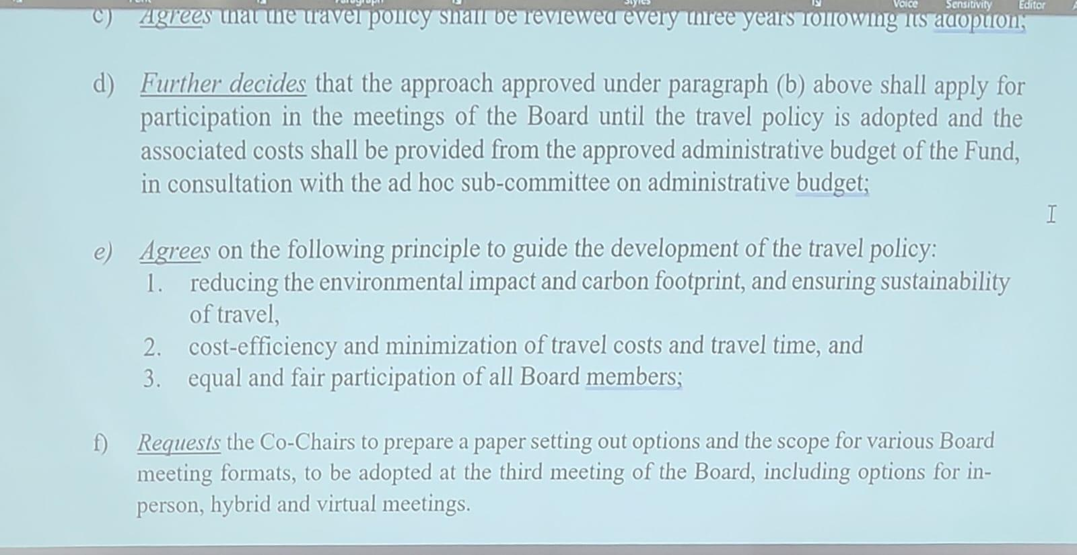
Other comments from the board members:
[Amb. Mo]
- Asked why there was a question on the participation of advisors and alternates. Understanding the efficiency and legitimation of travel fees is important, but concerned that the board is talking about the efficiency of travel costs for developing countries but is silent on the cost of administrative fees (referencing the World Bank’s representation of potential administrative fees in Day 3).
- Request further guidance on ways to mitigate environmental impact and carbon footprint and delete minimization of travel costs.
- Further in paragraph F, understand that virtual is part of the vision proposed by some colleagues, would only leave hybrid. If some colleagues don’t want to participate because of certain considerations, up to them.
- For developing countries in person is important. If the board is not considering the human dimension and finds cost-efficiency more important than that.
- Further raised paragraph 3 on reducing carbon impacts, changing principles to elements. Principles have legal implications.
- Paragraph F “challenges and opportunities” is important. For all that have mentioned cost efficiency importance, this should be applied across the board. This is important for everything.
- Reiterates that this is not about business travel. In the course of the discussion, he heard Ronan say that anything the board cut costs on would go to the community, reiterating to start with the big one, starting with the fees to the World Bank.
[Amb. Thompson]
Support the sentiments of Amb. Mo, further emphasized that the longest, cheapest mode of cost-effective is a false economy, money saved is penny-wise and pound-foolish, diminishing returns based on what is attempted. There are now measures used by airlines that mitigate the impacts such as offsets, as ways to reduce carbon footprint (a reference to paragraph e.1).
[Victoria]
Further reiterates not using the word “principle” because it is putting forward different ideas (i.e. cost-effective). Reiterated that the board should prioritize the well-being of participants seeing as we have to travel long hours. Agree with the meeting format as raised by Amb. Mo, and don't agree that virtual meetings would suffice. Paragraph f should be re(phrased).
[Jens]
- Reiterates that nobody can disagree with the notions of the wellbeing of the participant. Thinking that the principles should be more that we reduce to ensure sustainability in the whole package that relates to travel.
- Including observers the number of meetings and the way the board holds the meetings.
- Would want to retain the bullet related to ensuring the sustainability of travel. Paragraph F, from their perception, is important that virtual meetings are kept on the table. If the board changes to ensure that is a part of the options and is also part of the way the board is working. Further mentioned at the last meeting to see a paper from the budget subcommittee that assesses the impacts of the policy so that the board can have a better knowledge base to design our decisions.
[Elena]
Agree with the principle of discussion and elements of the travel policy. Elements rather than more rigid principles. Need to guide the travel policy. Coming from a region that is far away, the board has to consider when the papers are released and when they start our days or wake up for this virtual meeting.
[Mohammad]
- Raised a point on reducing carbon footprint and to reduce the impact, a baseline is needed which is currently not available to the board for discussion.
- In paragraph F, raised that instead of the co-chairs, put “request the interim secretariat to prepare a technical paper setting out options for formats for various…board-related meetings, including Board Meetings, for the consideration of the Board at the third…including challenges and opportunities for in-person and hybrid meetings.”
[Jose]
Happy to agree to the initial proposal. Agree on the points on cost-efficiency. Further, reiterate that the board should talk about principles because it is important to have a common way forward.
[Alpha]
- Fully support the views expressed by Amb Mo, Amb Thompson, and Mohammad. Was supposed to be an advisor however, the three African Board members are unable to attend. Reiterates that each board member and each alternate have an advisor.
- Supports the submission of Amb Mo and Mohammad and would like to consider the role of co-chairs in paragraph F. Reiterates that virtual meetings for LDCs present difficulties, and LDC’s point of view needs to be considered.

[DJIBRIL]
Agrees with the proposal raised by Mohammad. Reiterated the need for an in-person meeting as virtual meetings with varying time differences are difficult.

[RONAN]
Agrees with Jose and Amb. Mo’s points on carbon footprint and well-being. Raised that the board needs to acknowledge that there are challenges with online meetings and urges to look at innovative ways, aiming to operate in new more efficient ways including virtual options.

[GEORG]
Supports the language that was put forward by the co-chairs. Not sure how they can have equal participation of the board and advisors but can be discussed by the board.

[WGC]
Reiterated the importance of allowing travel support for observers from developing countries, which should be included in the decision at a bare minimum. Co-Chair JC responded that this will be addressed in the travel policy and active observer policy.

[Rebecca]
Agrees with Amb. Mo’s point is that the board doesn't need to ask for papers just to ask for papers. Responds to Adao’s point on making sure LDCs have connectivity, and should be explored further. They can look further at how to increase connectivity, and connection with the WB and other institutions and ask them, and further seek out ways to make virtual work for everyone.

[Co-Chair JC]
Raised that there is not much new, the board has gone through much of what was discussed this morning. This is more taking into account all the concerns and considerations, good to be heard – to some extent, then the board has difficulty finding out the solution. His is that the board is not going toward the solution at this stage, suspend, consult, and come back in the afternoon.

[CONTINUTATION OF DISCUSSION at 2:42 PM]
The Co-Chairs invited the board to discuss and approve the updated paragraphs:
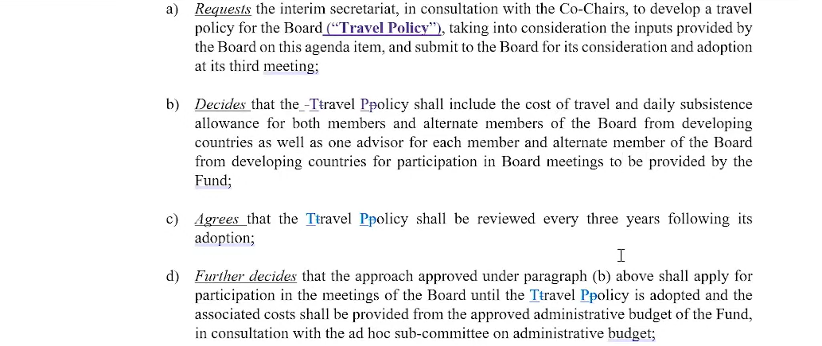
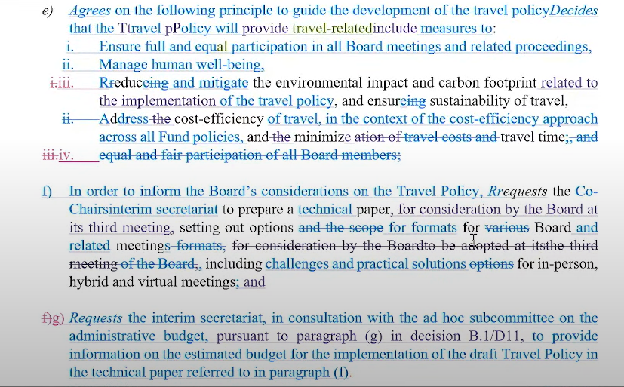

PARTICIPATION OF ACTIVE OBSERVERS IN THE BOARD MEETINGS AND RELATED PROCEEDING
The Co-Chair (Richard) raised that the decision should be discussed in principle, citing more work that needs to be done and considering the option of interim practice since B1, raised for the board and secretariat to try as much as possible to do work for B3 to resolve the matter permanently.
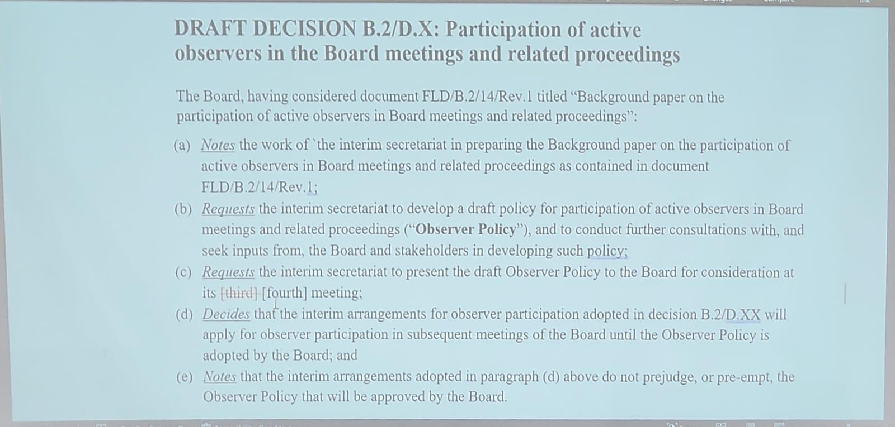

Most of the board members expressed support for the engagement with the CSO during and in between the meetings. Board members raised the strong diversity and large number of developing country participants of CSOs attending with most of the points raised forwarded. Expressed his appreciation of the role, and urged for an increased number of developing countries' representatives. Agreed that interventions from CSOs add a lot of value, good examples in the Board to find ways to facilitate an environment for discussion and exchange of ideas.
ARRANGEMENTS FOR ESTABLISHING AND OPERATIONALIZING THE ANNUAL HIGH-LEVEL DIALOGUES
The Co-Chairs came back with an updated draft decision considering the views of the board members from the previous session. The final draft was adopted by the board.
Raised the consideration of a hybrid approach for this year and next year, considering differences in languages on COP/CMA or UNFCCC. The points discussed include the launch of the high-level dialogue alongside the COP29 in person in Baku. Further, agrees that the HDL will take place in 2025 with a date and venue to be informed. Change in language referencing to COP29/CMA6.
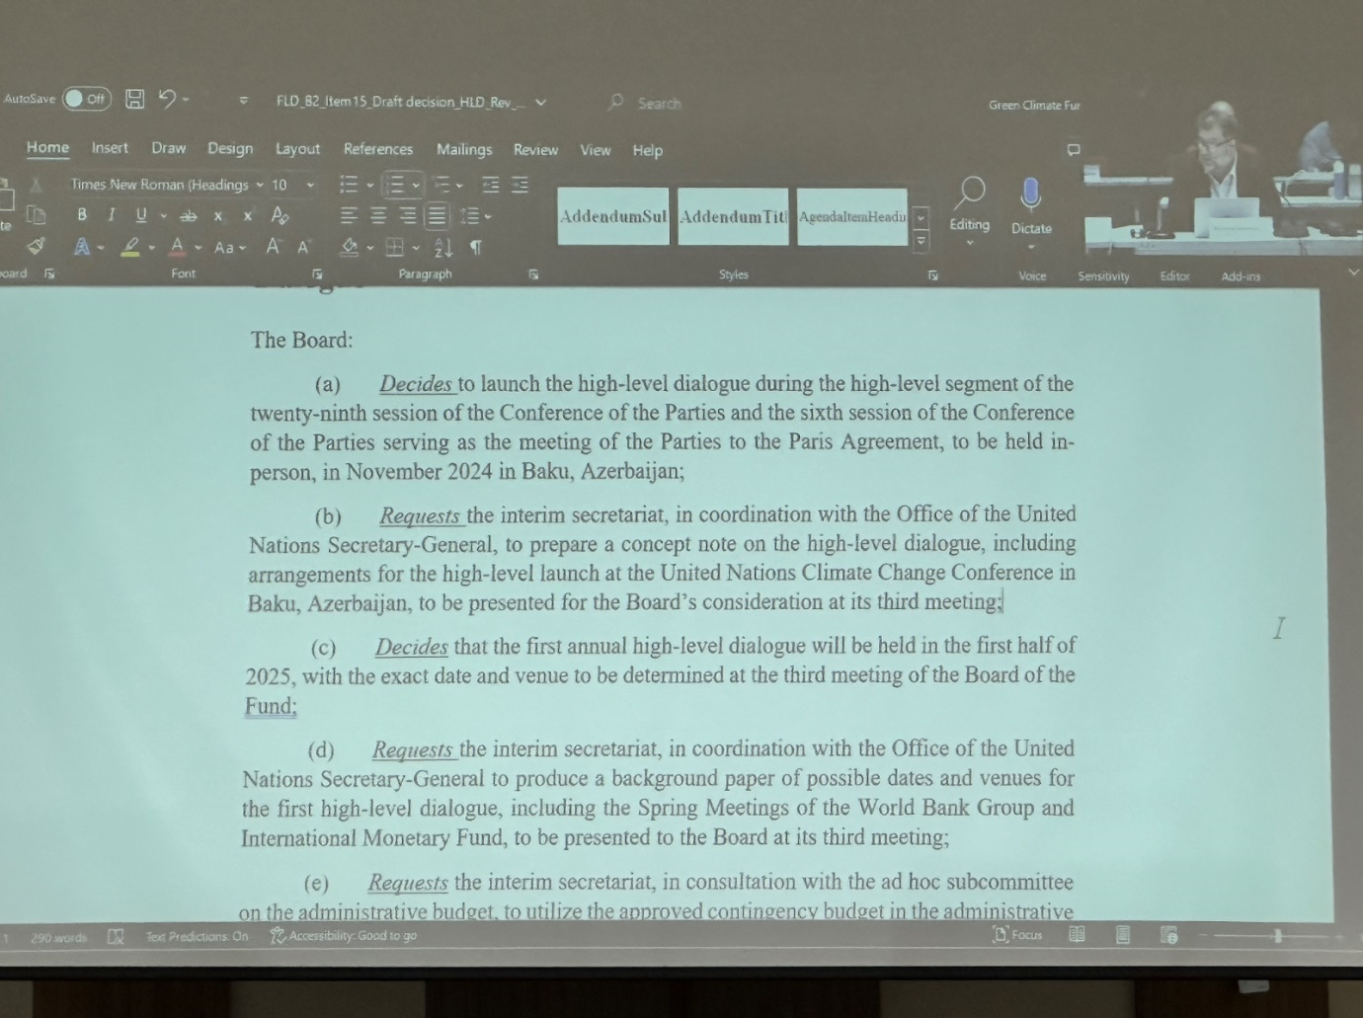

Back and forth between the Interim Secretariat and UNSG office – FfD Forum as suggested is not the most appropriate venue – this is the annual forum, not the High-Level FfD Conference. Instructed the Secretariat to return at B3 with the date and time for HLD and this high-level launching and work on concept notes for those two events.

The Co-chair further elaborated on the understanding that complementarity and coherence will be further developed, and what this does is buy us some time (2 Board meetings) and also do the broader work on the coherence with the funding arrangement.

DATES AND VENUE OF FUTURE MEETINGS
The Board adopted the dates and venue of the next meetings:
- B3: September 18 to 20, 2024 (Wednesday - Friday), Baku, Azerbaijan, as offered to be hosted by the incoming COP29 Presidency. The Board members thanked the incoming Presidency for this offer.
- B4: In the draft decision text, December 2-5, 2024 was initially agreed upon at B1 Abu Dhabi, pending the host country and interim Secretariat’s agreement for the 4th meeting. Mark Joven from the Philippines reiterated, in his intervention, the country’s willingness to host the next board meeting following its awarding as the board’s host country last July 9, 2024 (Monday).

Other comments from the board:
[Hana]
- Emphasized the importance of being ready for B3 and the business plan of the fund need to be discussed through informal or Chatham House settings etc.
- Given how close this meeting is, she reiterated that there is a need to receive documents earlier and find ways that the board members can have a virtual meeting.
- Further noted that it is important to have continued global solidarity at the political level. Hope it guides the board’s vision moving forward and continues to build that business plan as we continue to move forward.

[JC]
- Reiterated that trying to find innovative ways to engage is important, but the board has to be realistic and co-chairs need to manage expectations. Learning from the experience of B2 is not bad, the board did a lot but not perfectly.
- The goal of the co-chairs is to ensure that board members engage constructively and potentially decide, but pointed out that they won’t have the the documentation that we would need to engage on operational measures.
- Citing examples raised by other board members such as the rapid disbursement will not be ready for B3, ED Selection will be tough with this tight timeframe, the FIF documentation on the way to Baku, etc. The co-chair reiterated that the board will make progress on common understanding, but we have to be realistic and be ready for less than could have been expected maybe at another (later) date.
[Georg]
The schedule of the next board meeting creates new problems for board members who have already made plans to travel to London or New York/UNGA. Reiterates further that this means participation in the meeting would have to follow our political direction.

Workplan
The Co-chairs presented a draft document on the work plan, of which the document with amendments raised by Board members was adopted. Noting particularly that the Board recognized a lot of work needs to be done going towards the next board meetings, suggested that the draft be a rolling/iterative document, and further update and adjust the work plan as appropriate. 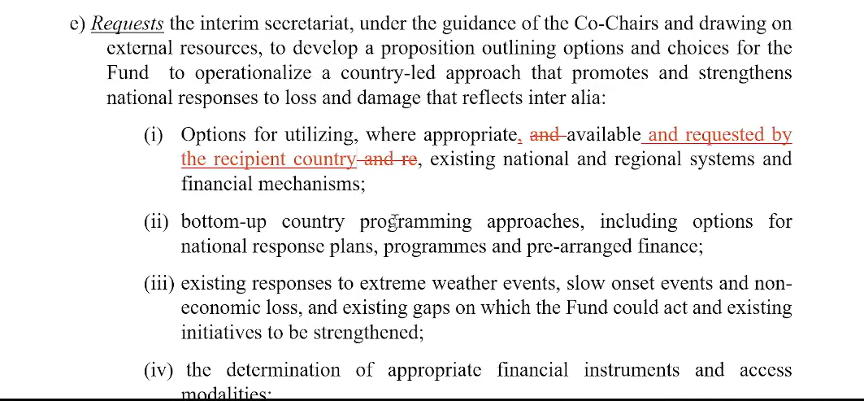
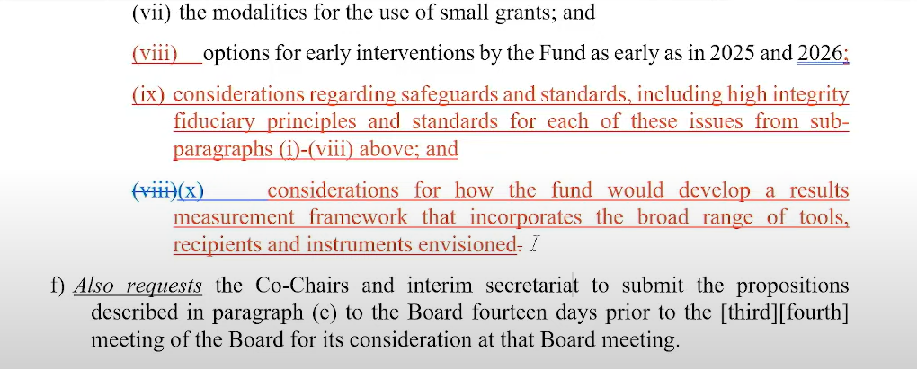

The Co-Chair reiterated that the proposition made throughout the day paragraph includes issues on trying to capture a country-driven and country-led approach instead of pure top-down mechanisms. Further noted that this work may require external sources, hence, they will discuss with the budget committee. In regards to this, the Co-Chars will start the work at B3, provide an initial concept sketch, and request the Board’s comments noting there is a lot of flexibility, not a fixed term of reference, and potentially adopt a document by B4.
Other comments from the board:
[Amb. Mo]
- Reiterated the challenge of the limited resources of the interim Secretariat and the resources needed for the next few meetings. Noted that the range of resources should not be just confirmed to the World Bank.
- Further reiterated that Amb. Mo’s seat/constituency has a clear request on a direct budget matrix which is important to all board members/constituencies.
- Further reiterates the operationalization of the Governing Instrument on access modalities, and that the criteria identified by institutions identified in the GI are the basis/entry point for identifying the functional equivalency. Citing that this is not clear in the current draft work plan document.
- Notes that more discussion is needed if the board brings forward elements such as the high fiduciary principles and standards or related terminology, noting that these often become a challenge for adaptation and loss and damage. Have all agreed to the principles of safeguards but we have an experience from the GCF where the highest ones led to complexities.
- More of a procedural point – para. 6 of the document and propose the addition of “and consultation with the observers” – the observers do not have the standing to propose the language
- Under resource mobilization, we hope that we can finish on time, I think that the proposal there would push us to deliver. I would not like to have the brackets around everything.

[Mohammad]
- Noted that a work plan can be agreed upon more appropriately by B3. Citing the difficult tasks of the Co-Chaord to put together the board’s work plan, with a lot of elements but the board would need more time to review and discuss.
- Raised that all the discussions are linked to scale, addressing the needs of developing countries, will not be realized without a long-term resource mobilization strategy. If not available by 2025 (B6), cities that the board would have a strategy by 2027 earliest. Which means the fund will remain at around 600 billion. 100 million of which would go to the WB in fees, 500m in that period for developing countries, would result in 3.2m per country which is a small grants fund. Already agreed that we envision the fund to grow and scale up. Need to have a strategy in place to do that
- Suggests two approaches we can take: (1) adopt and endorse this and identify the next steps Or (2) put everything in the annex, take notes, and ask co-chairs to develop an agenda for B3, and at B3 the Board think strategically about this. Further notes that he goes with the option of taking note of the annexes - agenda for B3 and on B3 we adopt a work plan.

[Gerard]
- Raised that the Board needs to adopt a coherent vision, with a strategic results framework over time. Line of sight for this work plan would mean more substantive and strategic discussion, with the Co-chairs building on the momentum.
- Further raised a more detailed set of options for the development of a country-based work plan. An illustrative example of what this bottom-up approach would look like is needed. Important to focus on its, risk of overlying and making it too complex and risking our timetable.
- Referencing Hana’s point that flexible modalities and time and flexibility, the Board does not have a lot of time for intercessional work, but the Board may start and use time for B3 and B4.
- On the range of sources, further raised the assumption that this is not just WB, but the diversity of thought across our membership. As such also that the active observers can also have input on informal and active process.
- Agreed on the points raised by Rebecca and the board has to start talking about resource allocation and prompt start funding. Maybe the board may start to think about what the prompt start funding could look like – some countries have already pointed out the priorities of funding.
- A propositional approach is very much appreciated - stepping back a moment, draws optimism from this.

[Dan]
- Reiterated that his seat stresses the need to make sure that the board has a plan moving forward, not just for operational but also for the optics.
- Welcomes the paper that is proposed in the process. Raised that the focus on country-ownership and country-led approach is not just a certain area the board should explore but also the prominent element of the GI, as well as differentiation with other funds. Note that the big part of the gap explored during the TC was the bottom-up approaches.
- Noted the section on complementarity and coherence, which may also work with country-led approaches complementing what is existing, not focusing on the internationals and the existing mechanisms.
- Raised the need to sketch a blueprint that will guide the formal design work more than a hard and fast framework.

[Adao]
- Raised the context of pre-arranged financing, which should not include complex data to get financial support for pre-arranged support. Further, reiterate that there’s a need for clarity about these pre-arranged financing issues.
- In relation to the points by Mohammad on resource mobilization, the current pledge is far from the needs of developing countries, needs long-term planning on the issue, and also needs to take into consideration the HLD role in resource mobilization
- Raised that approach or action the Board will take on the issue of resource mobilization for COP29/CMA6.

[Co-Chair Richard]
- Further reiterates that the provisions are taken from the GI and that the GI is clear that the Board should utilize an existing national system and financial mechanisms, and explore better ways for running a fund instead of a top-down approach.
- Adopted decisions by the COP and the CMA bind the board and Fund to the agreement. The issues of incomplete data are captured under the GI in the country ownership section. Strongly suggest not using this process to re-negotiate the GI.

[ENGO]
- Quick intervention to support and concretize on ensuring the observers' views are taken into account. Particularly adding “and in consultation with observes” in paragraph 6 of the Annex.

[Jose]
- Expresses explicitly his support for the participation of active observers.
- To manage expectations (on the draft document), raised that these are only initial recommendations, but not everything will be captured by August 15th.
- Further raised that the Board is very ambitious on the language in resource mobilization but think they can agree to finalize this by B6.

[Djibril]
- In relation to the issues of environmental integrity and social safeguards, raised when concerns related to the urgency of loss and damage for LDCs, it would be very difficult to comply with some kinds of criteria, and it will bring them in the same kind of difficulties as in the GCF. How LDCs can have some flexibility when these are applied and see this as a country-driven process. Want to take some concrete activities in LD areas, particularly for extreme events. Raised that when a country is in extreme events, how can the Board ensure high integrity of environmental and social safeguards?
- Further raised that it is clear for LDCs, that they do not need to duplicate or to repeat the same complexity even though they know the importance of safeguards, but they also need to be realistic. LDCS and developing countries can have the possibility to take concrete actions based on national circumstances to avoid complexity. Countries will not advance in their efforts to address loss and damage issues.

Additional Rules Of Procedure
The Co-chairs returned the discussion on agenda 8 on the additional rules of procedure. Of which a draft text was circulated to the Board ahead of the meeting, and an addendum that reflected the work that happened over the last three days of the meeting was properly led by the Co-chairs Anna and Elena. Elena highlighted points on the addendum as follows:
- Received the background document before B2, the draft that we worked on before B2. Since that initial report the committee has met three times, and worked through different elements outstanding:
  - Tried to based on conversations with co-chairs – initially not addressing
    - Format of meetings, under CChairs consultation
    - Travel policy
    - Definition of regional entities and nomination of Board members
  - Focused on the other unresolved issues:
    - Interventions by Board members
    - Languages of certain documents
    - The decision between meetings by the Board or ED of the Fund
  - In discussions we had – additionally written comments by committee. members, evolving, considered them at the next meetings
  - Find some convergency on some matters:
    - Interventions made by the Board – eliminated
    - The issue with continuing meetings with single co-chairs was removed.
    - Addition of provision on business continuity – transition period between co-chairs, until the period is out.
    - Cannot reach conclusions on certain definitions, section 2 r; how to define “parties”, how we define regional constituencies.
  - No consensus on:
    - Member of the committee requested that we express that the delegation of rights to express views - para. 17 of the draft rules – delegation of views of members
    - Another member of the committee requested to record a no consensus on decisions between meetings, (now 53 paras)
- After several meetings and comments received, needs to be further considered by the Board, and should be under the guidance of the Co-Chairs of the Board, this is how far we have come.
- Next steps: like the Board to consider giving us more time to resolve the outstanding issues, consult with the broader Board, and allow for further consultations and guidance from the Board.
- Submit a new draft of the rules of procedure at B3 – background document with the addendum

[WGC]
- Raised question on the opportunity for the observers to comment on the addendum. Co-chair JC answered that as per mandate stipulates consultations with observers are required, which will be facilitated by the co-chairs of the committee.

Closing
Co-chair Richard presented the summary of milestones:
- Conclusion and successful exhaustion of consensus for the host country of the board
- The selection process for the ED, timeframe, and job description, puts us well in time to have an ED by B3, who can hire
- Adopted a work plan for the board which sets out our priorities for the coming year
- Approved the governance arrangements to be approved between the COP/CMA and the board
- Adopted interim arrangements for us to decide between meetings
- Adopted interim COI
- Adopted formalized interim active observer participation
- Adopted process to launch first HLD annual dialogue on FA, and agreed would host it in 2025
- Resolved the matter of the name of the fund
- Interim set of approaches to the travel policy
- Committees have been working and delivering - doing an important job of going through the politics of where the different positions are. The host country Subcommittee has successfully finished its job;
- The next committee to finish its work will be the AROP.

