Prepared by: Marissa Lerner
Date: 04 December 2018
Session/Agenda Item: SBI/SBSTA informal consultations on report of the Executive Committee of the Warsaw International Mechanism for Loss and Damage associated with Climate Change Impacts
Location: UNFCCC COP 24, Katowice
Room Number: [Bałtyk Meeting Room 2]
Date and Time: 4:38- onwards (I came in 8 min after start)
Notes/Summary:
Note-taking key:
[...] = I missed this…
__Country speaking___ (On behalf of…)

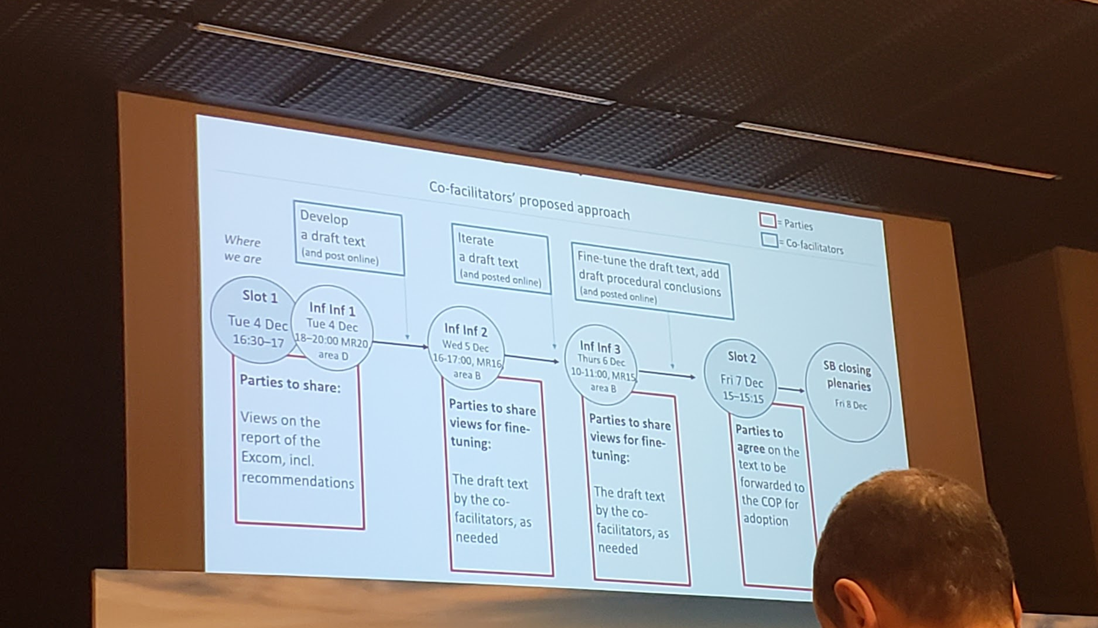

Australia:
- I was co-chair on displacement, I want to explain what the task force did
- We had experts from across UN, society, etc
- That work had 100s of findings, many technical papers & analysis. Workshop in May. 100 delegates form UN, society, agencies
- We compiled those findings
- Recommendations in this report are “very well thought through”
- We’re happy to share those ideas
- Has been talking for about 5 min now… thanking everyone
Sudan:
- Thanking Australia because feels we have been allocated very little time so it’s helpful to know what happened and have that resource for further
- On behalf of AGN, wants to thank stakeholder consultation, task force on displacement, excom report
- Task force on displacement → a lot of information that NEEDs to be considered by excom when implementing place
- Decisions need to be visible. Not just embedded in the report.
- Sitting in the excom, we know the mentality coming from these recommendations.
- Outsiders need to know this to be able to follow implementation
  - Suggestion made by St. Lucia is welcome (missed this as I was coming in)
- [...]
LDCs (didn’t catch who’s speaking
- We support your approach
- We are having VERY limited time to negotiate this as an item, but we are really happy bc we are working out a way to approach this as an item ahead
- We really appreciate the work done by the excom and how it was supported by the Secretariat
- How to work with this ahead?
  - LDCs would like to support views of St. Lucia on behalf of AOSIS
- We believe that all recommendations are critically important. We need to [...]
- A-K will be in decision body
- The rest will move to be annexed
- Would like to endorse decision by EXcom to extend the task force (?)
- Want to support views by Af. Group
- Request excom to incorporate findings of this report in ongoing plan to be helpful for developing countries
- Request SBs to incorp. Findings into work, esp for developing TUR for WIM review
- We are ready to be engaged for the next few days on this
United States
- Thanking excom
- I think the recommendations on displacement represent quite a bit of work behind them and we agree with others on this
- Ideas shared this morning
- Specifically need to number paragraphs on those from excom vs. those from parties.
- Task force work is important but we hesitant to bring them into COP decisions at this stage
- Clear signal to actors and parties that they can take these into account with their work w/out needing to stop discuss the reasoning for how decisions were made
  - (I’m assuming he’s talking about a measure of ‘objectivity’)
  - Happy to talk with others about this
- Given amount of common views shared here we should hopefully be able to come together to a consensus on this
Canada
- Thank you for laying out a very clear path for us
- Proposal from AOSIS could be interesting to explore for further
- Thanking colleagues from Australia and Sudan and their work on the task force
- We look forward to engaging in informal work
EU
- We would like to see a rather short decision
- We welcome the report of the excom and the progress that has been made in implementing the 5 year plan
- Thank you for the work on displacement
- We welcome the recommendations of the task force
- [...]
We’ve met the time limit for today, no more interventions for now.
Honduras, New Zealand, and Norway up next in the inf inf

