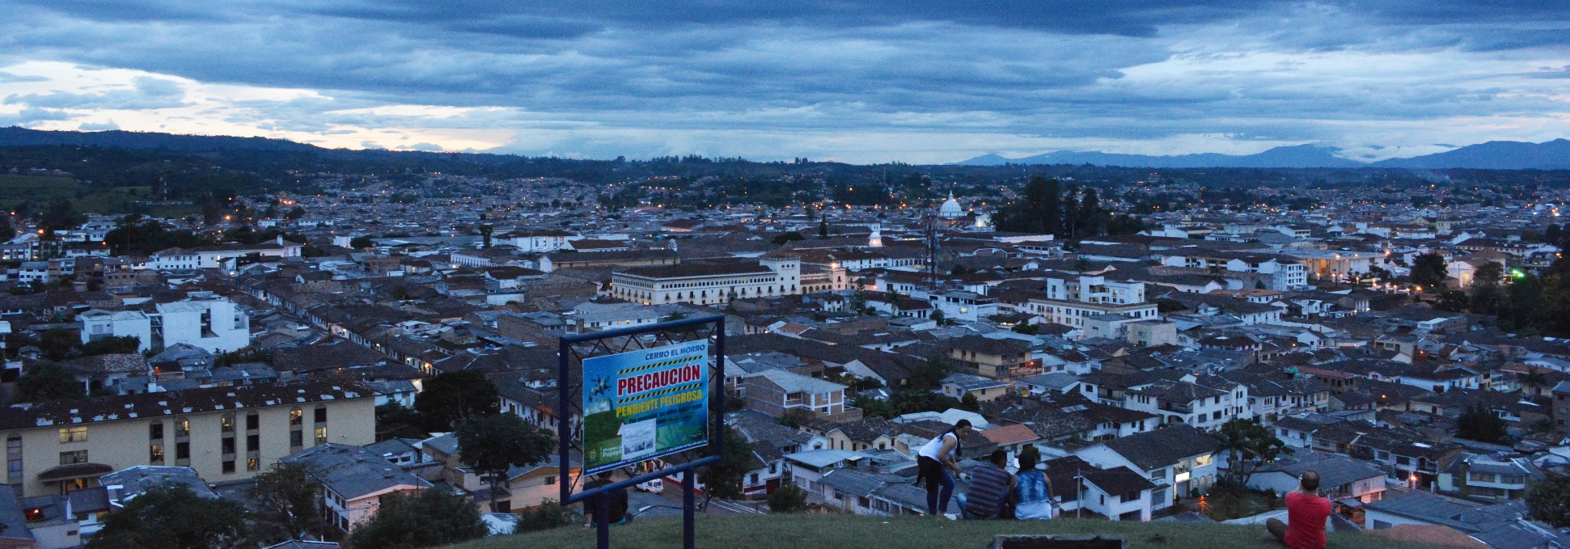
COP23 SIDE EVENT

Community-Based Adaptation:
Research, Practice and Partnerships for Resilience-Building
COP23 – Bonn, Germany
6 November 2017
11:30 – 13:00
Boon Zone
Meeting Room 4

Side Event Sponsors:

Moravian College (USA)
Trócaire (Ireland)
Research and Independent NGOs (RINGOs, a UNFCCC constituency group)

Moderator:

Diane White Husic, PhD
Dean, School of Natural and Health Sciences, Moravian College (USA)
Member of the RINGOs Steering Committee

Part I:
Setting the Stage: Research, Practice and Policy Instruments

Xiaoting Hou-Jones
Researcher, Biodiversity and Forest Team, Natural Resources Group, IIED (UK)
Ecosystem-based adaptation: Research and practice for effective adaptation

Japheth Muli
Resilience Programme Officer, Trócaire (Kenya)
Trócaire (Ireland)
Research in Kenya on the effects of gender, age, and ability on climate change adaptation.

Johannes Förster
PhD candidate, Department Environmental Politics
Helmholtz Centre for Environmental Research – UFZ (Germany)
Designing policy instruments for community-based adaptation in small island states: how an explicit focus on ‘ecosystem service opportunities’ can inform adaptation options

Q/A for first 3 panelists

Part II:
Resilience Building – Working with Indigenous Communities and Informal Settlements

Christopher P. Dunn, PhD
The Elizabeth Newman Wilds Executive Director, Cornell Botanic Gardens
Cornell University (USA)
Climate adaptation and resilience in local and indigenous communities in USA and Central Asia

Ruth Zenaida Buendía Mestoquiari
Vice President, CARE Central Ashaninka del Río Ene (Peru)
2014 Goldman Environmental Prize Winner
Economy: Cacao and our rainforest

Nicola Tollin, PhD
President, Recycling Cities Network International, RECNET
Executive Director, International Program on Urban Resilience, RESURBE
Community base adaptation in informal settlements in Colombia: Best practices in community resilience

Q/A for second set of panelists

Part III:
Models of Knowledge Sharing and South-South Cooperation for Adaptation

Diane White Husic, PhD
Dean, School of Natural and Health Sciences, Moravian College (USA)
Community-based adaptation conferences and the TEC Adaptation Taskforce work on South-South and triangular cooperation

Sidat Yaffa, PhD
Associate Professor of Agronomy and Acting Director of UTG/WASCAL Masters Research Program on Climate Change and Education, University of The Gambia, Farafenni Campus (The Gambia)
LUCCC: the Least Developed Countries Universities Consortium on Climate Change

Open Discussion:
Knowledge sharing, research gaps, and vertical integration between national policies and local actions

Additional Q/A
